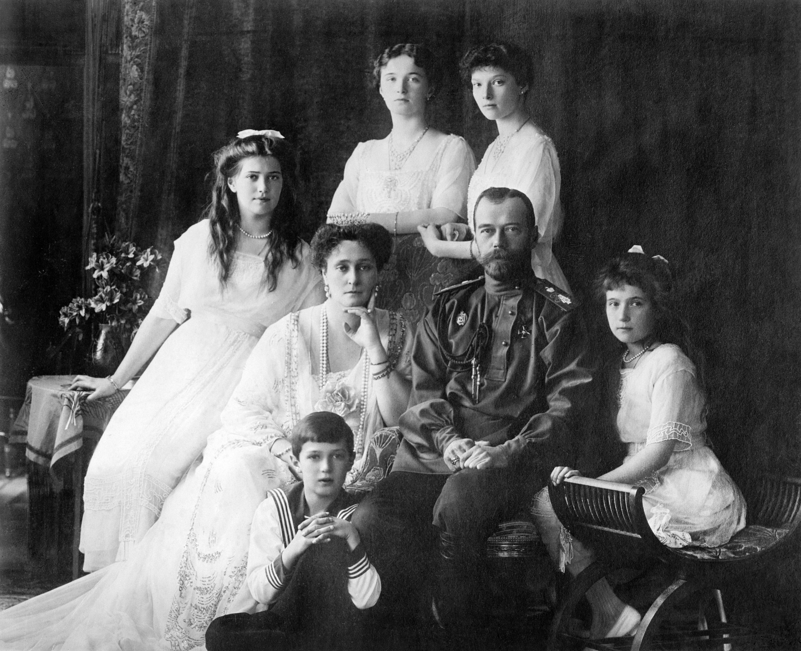
End of a Dynasty
As their world spun out of control in a storm of war and revolution, Nicholas and Alexandra had just one constant to cling to--their everlasting love for each other and their children.
The charismatic Rasputin stirred strong feelings in St. Petersburg society. Although he had many devotees, including the Empress Alexandra, who swore by his miraculous powers, he also had enemies who believed his influence to be sinister and corrupting. By 1912, all this attention had gone to his head and he began to abuse the power he held over his more gullible followers.
Tales of his lasciviousness and drunkenness swept St. Petersburg. But from the start, one devotee refused to listen. In Alexandra's eyes, the uncouth peasant with thick dirty hair, powerful staring eyes, and a liking for liquor could do no wrong, and when rumors against him were reported to her, she put them down to jealousy and class prejudice. Increasingly, she turned to him for advice and guidance.
The appearance of such a figure in the inner circle of the Imperial family caused a great stir. Rasputin even kept his gruff speech and manner when he was with the royal couple and spoke as informally to them as he would to commoners. There was a rumor that he had some strange influence over them.
One man who dared to speak out about Rasputin's influence was Nicholas's Prime Minister, Peter Stolypin. He was that rarity, an able statesman who was also completely loyal to the monarchy. But he had become alarmed by the clearly scandalous hold that Rasputin had over the royal family and, for this he incurred the displeasure of the Empress. At first, Nicholas hesitated to act against his Prime Minister, but gradually he yielded to Alexandra's pressure, and ordered that he not speak of Rasputin in his presence again.
Malicious Rumors
To many people, it seemed that Russia was being governed not by Nicholas and his ministers, but by his "scheming" wife, aided and abetted by the "evil" Rasputin. Alexandra had always appeared too aloof and reserved to become popular with the Russian people. Now, she was becoming hated, and there were wild and malicious--and quite untrue--rumors that she was Rasputin's mistress, and that her daughters were being brought up in immoral ways. Nothing, of course, could have been further from the truth.
The outbreak of the Great War in 1914 temporarily strengthened Nicholas's position, as Russians responded to the patriotic call to defend the motherland against Germany. But Nicholas did little to maintain this confidence. Patriotic organizations were thwarted in their efforts, the new parliament, the Duma, was slighted, and the gulf between the people and the Imperial family grew. The situation worsened when Alexandra turned Nicholas's mind against his cousin the Grand Duke Nicholas, the popular commander-in-chief of the armed forces. Fearing a threat to the position of her revered and beloved husband and blinded by unswerving devotion, Alexandra's own judgment had become increasingly uncertain.
Worst of all, the armed forces were faring badly at the Front. The Germans had inflicted several humiliating blows on them, and on 5 March 1915, against the advice of his army chiefs, Nicholas dismissed the Grand Duke, assumed supreme military command and went to the Front himself.
In his absence from St. Petersburg, supreme power passed, with Nicholas's encouragement, to the Tsarina, the only person on earth he trusted completely. In the midst of a desperate war, Russians watched horrified as Alexandra dismissed competent officers and replaced them with worthless nominees of Rasputin. Eventually, in December 1916, a group of nobles led by Prince Yussoupov decided to act. Poisoned with cyanide, shot in the head and body, Rasputin finally died by drowning, after being pushed through a hole in the ice of a frozen river.
Alexandra, who was shattered by news of the assassination, never gave up her faith in the saintliness of "our friend", as the royal family always called Rasputin. In return, she became an object of hatred and suspicion throughout Russia, dismissed contemptuously as "the German woman" and suspected by many of being a spy for Russia's greatest enemy.
Few cared to look at "the other side" of Alexandra, the caring and sympathetic human being who, at the outbreak of hostilities, had set up a hospital for the war wounded at Tsarskoe Selo and who, despite her own ailing health, worked long hours as a field nurse in the army and Red Cross medical units. To her enemies, such obvious patriotic devotion to her fellow citizens meant nothing. Although Alexandra herself refused to contemplate it--in fact, she never did accept it--the fall of the Tsar was imminent.
Call to Abdicate
On 5 March, 1917, Nicholas sent from the Front what was to be his final telegram to Alexandra: "In thought I am always with you and the children. God bless you. Sleep well. I kiss you tenderly."
Three days later, serious riots broke out in St. Petersburg (by name called Petrograd). Nicholas sent orders to his troops in the city to crush the revolt. But it was too late. Instead, the soldiers joined the uprising, and both they and the new representative assembly called on Nicholas to abdicate.
On 15 March, with great dignity, Nicholas renounced the throne--at first in favor of his son, but then, realizing that the sick child must be spared such an ordeal, in favor of his brother. "I trust you will understand the feelings of a father," he wrote to his new masters. Nicholas's brother Michael, however, refused the crown.
All through these tense days, Alexandra was without news of her husband. At Tsarskoe Selo. she could scarcely master her anxiety. The Emperor usually answered her telegrams in a matter of hours. Now there was silence, and it became clear to her that the Revolution had spread beyond Petrograd and had reached the troops at the Front.
On the evening of 13 March 1917, the Tsarskoe Selo garrison itself, which until then had refused to join the rebels, left the barracks and marched out, firing haphazardly into the air. Hearing the news, Alexandra threw a black fur coat over her white nurse's uniform and went into the snowy palace courtyard to rally the Palace Guard.
Walking from man to man, Alexandra told them that she had complete confidence in them, and urged them to remember that the life of the young Tsarevich--the heir of Russia--was in their hands. She even asked them, stiff with cold as they were, to come into the palace to warm themselves. The move seemed to work--temporarily, at least.
Inside the palace, the night was passed in great anxiety, despite the great number of now loyal guards outside. Alexandra had received a report that an armored train manned by rebel soldiers from Petrograd was moving towards the Imperial station at Tsarskoe Selo. It was rumored that the revolutionaries were anxious to get their hands on the Tsarina and her son, to hold them hostage in case the tide of favor turned against them. Other rumors said that they had sworn to murder her. Whatever their intentions, on reaching the actual village of Tsarskoe Selo, they became distracted and ran amok. Thoroughly and drunkenly aroused, several of them then set off for the Alexander Palace, where the Tsarina and her family were staying.
At the last minute, tragedy was averted, however. The rebels eventually withdrew because of reports that immense forces were massed to protect the royal family.
On 21 March 1917, the day before Nicholas was at last expected to rejoin his family, Alexandra was officially placed under arrest by the new provisional government headed by Alexander Kerensky.
Sombre Return
Alexandra now had the difficult task of explaining to the children what had happened. They took the news as bravely as their mother had, and did their best to cheer Alexandra by speaking with joy of the one scrap of happy news--their dear father's return the next day.
On a cold gray morning in March 1917, Nicholas, no longer Emperor, returned to the palace at Tsarskoe Selo, where his family were now being held as virtual prisoners.
His car was stopped at the gates. "Who goes there?", was the challenge. One of the soldiers answered, "It is Nicholas Romanov". After some negotiation, the car was allowed to drive up to the palace entrance. By their deliberate indifference and lack of respect, the soldiers showed how they now intended to treat their former sovereign.
Nicholas got out and crossed the great hall of the palace. Mechanically, he saluted the score of officers who watched him curiously. Very few of them returned his salute. Then Nicholas went at once to his children's rooms where Alexandra was waiting to meet him. Their relief at finding each other alive, their pleasure in each other's company, were the only consolations they had.
The family were now prisoners in their own home. During the first weeks at Tsarskoe Selo, Nicholas was allowed to go out for short daily walks, accompanied by soldiers with fixed bayonets. But he preferred to exercise by shoveling snow, rather than walk around and around in the limited space that was offered him.
Alexandra did not go out at all. She and the children spent each day in their rooms. The evenings they spent together were filled with unspeakable sadness.
Royal Prisoners
Nicholas's treatment at the hands of his revolutionary jailers grew steadily worse. Every time he ventured out, he was insulted to his face, baited and humiliated. On one occasion, when he took a bicycle ride in the gardens, a soldier deliberately stuck his bayonet in the spokes of the wheels, causing the former Emperor of Russia to fall helplessly in the snow while all around laughed at his plight. Through al this, Alexandra lost weight rapidly, aged noticeably, and sat for hours on end in almost total silence.
Meanwhile, as the revolution in Moscow and Petrograd was taking its unpredictable course, no-one seemed sure what to do with the Imperial family. There had been talk of Nicholas being put on trial. Then the Provisional Government planned that he and his family should be allowed to find exile in England. But instead, mainly due to the opposition of the Petrograd revolutionary workers' and soldiers' council--the power base of Lenin, Trotsky and the Bolshevik Party--the family were moved from Tsarskoe Selo to Tobolsk, in Siberia, where their treatment improved somewhat. Many local people felt a sentimental loyalty to the Tsar and attempts were made to make their detention as reasonably comfortable as possible. Alexandra spent her days lying on a sofa and knitting, while Nicholas would read aloud to his children.
In October 1917, Lenin took over the reins of power. The advent of Communism sealed the family's doom. In 1918, they moved to Ekaterinburg in the Urals. When the anti-Bolshevik White Army approached the area, the local Communists were ordered to prevent a rescue.
The decision was made to execute the royal family and to destroy all evidence of the deed. Nicholas suspected that a change of plan was in the air. Although Alexandra had been tired and ill, he and the children had remained in relatively good spirits. Now Nicholas grew tense and watchful.
On the evening of 16 July 1918, the leader of the secret police guarding the Imperial family, Jacob Yurovsky, told his men, "Tonight we will shoot the whole family, everybody." The family went to bed as usual. At midnight, Yurovsky wakened them, explaining that the White Army were approaching and that they must be moved at once. Innocent of the fate that awaited them, the family dressed and went downstairs, where Yurovsky led them to a basement room and told them to wait for their cars to arrive.
Into this small room crowded Nicholas and Alexandra and their five children, and four members of their domestic household, including Alexandra's maid, Demidova, who carried some Imperial jewels hidden in the feathers of a pillow. As they settled down to wait, Yurovsky burst into the room waving his revolver, followed by his armed secret policemen. "Your relatives have tried to save you. They have failed and we must now shoot you," Yurovsky declared to the terrified group.
In the Hands of God
Nicholas hardly had time to throw a protective arm round his wife before Yurovsky pointed his revolver at the Tsar's head and fired. Nicholas died instantly. The armed men then opened fire, and the small room rang with shots and screams. Alexandra was making the sign of the cross when she fell dead, hit by a single bullet. The Grand Duchesses Olga, Tatiana and Marie also fell in the hail of bullets. The sickly Tsarevich was finished off by two bullets through the ear.
The Grand Duchess Anastasia, who had fainted when the firing started, now regained consciousness, and was set upon by bayonets and rifle butts. The Romanov dynasty--and with it, Tsarism--was at an end.
"I have a firm, an absolute conviction that the fate of Russia--that my own fate and that of my family--is in the hands of God," wrote Nicholas. He was to die as a martyr to circumstance, but the tragedy--and triumph--of Nicholas and Alexandra lie in their undimmed courage, and the supreme love that sustained them in their final days.
- Fin -

